Sevenoaks Volunteer Transport Group

Health and Safety Policy

These guidelines contain valuable information to keep you and your passengers safe on the roads.
As a voluntary organisation we have a duty of care, under health and safety law, where driving is concerned, to ensure the safety of our staff, volunteers and passengers as well as anyone else (e.g. other road users) who may be affected by our activities. When anyone drives as part of their duties with us both SVTG and the driver share the responsibility of making sure that the risks are properly identified and managed.

Legal issues
Before you start driving for SVTG we need you to confirm that you are:
- Legally entitled to drive the vehicle you are driving
- Using a vehicle that is safe and road-worthy
- Competent to drive it safely
- Using it for suitable purposes.

Even though you are using your own vehicle, SVTG is required to ensure that it is safe and adequately insured when it is being used as part of your volunteer role with us. Therefore before you start as an SVTG volunteer driver, and for as long as you remain one, you are required to ensure the following are in order for the vehicle you drive for SVTG work:
- MOT certificate
- Driving licence
- Insurance certificate
- Road tax status

Before you start as, and for as long as you remain, an SVTG volunteer driver, please also check that you are covered by your regular motor insurance policy to fulfil this role.
If you have any concerns or queries about the insurance cover you require, please contact us at 01732 458931 or via our website:

https://sevenoaksvolunteertransport.com/contact/
We have a duty of care to ensure you are safe and competent to drive on our behalf. Therefore, any motoring offences including speeding and driving without due care and attention, be they cautions, summonses or convictions, should be reported to us, even if they have been incurred while not driving for SVTG.

Fit to drive

A person’s fitness to drive can be affected by a medical condition, by temporary illness and by the environment in which they work, drive and live. Health impairments, including stress, sleep disturbance, migraine, flu, severe colds, and hay-fever can lead to unsafe driving. Sometimes, the treatment for these conditions can also impair someone’s driving.
SVTG needs to know when you are not fit to drive, for example when you are:
- affected by alcohol, drugs, or medicines
- affected by illness
- too tired to drive safely.

You should inform the SVTG Co-ordinator of any health issues, personal circumstances that may affect your driving, or if you are not feeling well on the day you are volunteering to drive for SVTG. You are also legally required to inform DVLA if you develop a notifiable medical condition, for example a stroke.

Eyesight
The minimum legal eyesight standard for driving is that you can read a new-style number plate (for example AB 123 ABC) at a distance of 20 metres (around 65 feet or 5 car lengths), or an old-style number plate (for example A 123 ABC) at a distance of 20.5 metres (67 feet).
If you need to wear glasses or contact lenses to enable you to do this, then please make sure you wear them each time you drive. It is strongly recommended that you have your eyesight checked regularly (at least every two years, or more often if your optician recommends it).

Alcohol and drugs
Avoid drinking alcohol in the hours before you will be driving. It can take several hours for alcohol to leave your body and you may still be over the limit or affected by alcohol the morning after you have been drinking. Alcohol impairs judgement, and can make drivers over-confident so that they are more likely to take risks. It slows reactions, increases stopping distances, impairs judgement of speed and distance, and affects vision. Even a small amount of alcohol, well below the legal limit, affects the ability to drive safely. Volunteers should have no alcohol in their blood when driving on behalf of SVTG.
Do not drive if you have taken any illegal drugs. They can affect your decision making and driving skills as well as your physical and mental condition and behaviour.

Medicines
Check with your GP or pharmacist whether any over the counter or prescribed medicines – including those described as being for use by children – you may be taking are likely to affect your driving, for example, by causing drowsiness. If so, ask for an alternative that will not. If there is no alternative, please avoid driving for SVTG. The DVLA asks that you inform them if you are taking certain medications. In these instances, please also inform your Co-ordinator.

Keeping your vehicle safe
Please make sure that your vehicle is serviced in accordance with the manufacturer’s specifications.
Regularly check the roadworthiness of your vehicle. For example, you should check that:
- Oil, coolant, and windscreen wash levels are correct
- Tyres are undamaged and have sufficient tread
- Mirrors are positioned correctly
- Washers and wipers are working
- All occupants are using their seat belts, and that head restraints are adjusted correctly

If you are in doubt about how to check any of the above, you should refer to your vehicle’s handbook, or seek advice.

Managing your speed
Always stay within speed limits – including variable limits and temporary limits at roadworks – even if you think the limit is too low. Make sure that you know the speed limit of the roads you are using and give yourself plenty of time for the journey so that you do not end up rushing and going over the speed limit.
When driving with SVTG passengers in the car please be mindful of your driving style. Avoid rapid acceleration or late braking and excessive speeds, and always consider the wellbeing and needs of your passengers as they may be nervous. Should a passenger become critically ill while they are out with you, call 999; or if you feel confident and that the passenger is not at risk, take them directly to the nearest Accident & Emergency Department.
If you are involved in a car accident, you must inform the police. Assuming there are no injuries you may need to arrange a taxi for your passenger/s. The cost of the taxi will be reimbursed. If you as the driver need to be admitted to hospital, please delegate responsibility for your passenger/s to the police.

Using your mobile phones
It is illegal to use a hand-held mobile phone while driving. This includes any activity that involves holding the phone such as dialling a number or writing a text message. It is also advisable not to use a hands-free phone while driving. Using a handsfree phone while driving does not significantly reduce the risks; the problems are caused mainly by the distraction and divided attention of taking part in a phone conversation at the same time as driving. If you need to use your mobile phone while ‘on the road’ please stop in a safe place before doing so.

Best practice for supporting older passengers into and out of your car
Some of our passengers may need a little help when getting in to or out of your vehicle. For everyone’s safety, SVTG has established guidelines for best practice:

What you should do
- Your passenger/s should have the capacity to enter and exit your vehicle with minimal support. If it transpires that they need more than minimal please let the Coordinator know.
- You can provide a supportive arm (images 1 and 2 below), but passengers must be able to move themselves in to and out of car seats.
- For older passengers who are using walking aids, please bring the aids as close as possible to your vehicle when they are getting in or out of your car.
- Open the passenger door fully and hold it so it does not swing shut. If required, the older passenger can hold on to the window ledge to support themselves as well.
- We can help passengers to fasten their seatbelts; however, this should be completed from the driver's seat and not by leaning over from the passenger door.

What you should not do
- You should never try to lift an older guest out of a car (image 3).
- You should never let the older person you are assisting hold or hug you around your neck while you are supporting them. This could cause serious injury to the passenger or you.

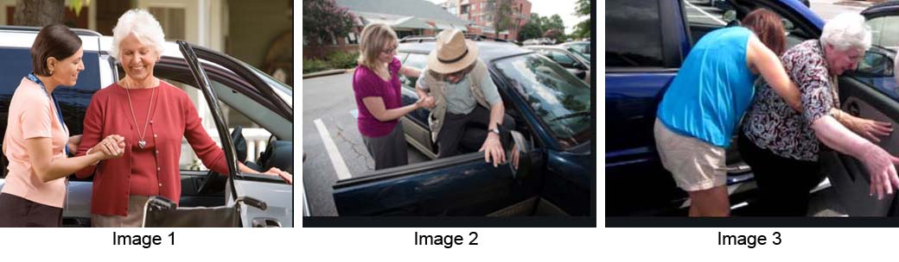
Adapted from:

https://www.reengage.org.uk/volunteer/resources/training/other-learning-resources/volunteer-drivers-reserve-drivers-guideline/

Graham Lacey
SVTG Committee member

May 2024

Policy to be reviewed May 2025

